12 – ReactJS-HOL
Implementation of Element Variables for Structural Switching
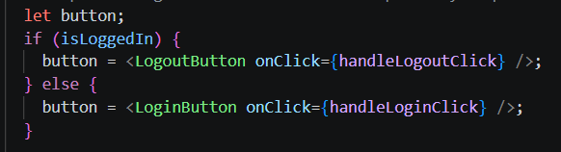
Layout Conditional Flow Engine Routing
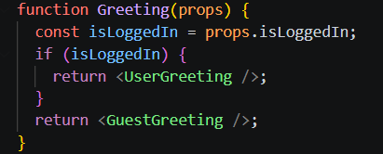
Core Feature Permission Gate Architecture Block
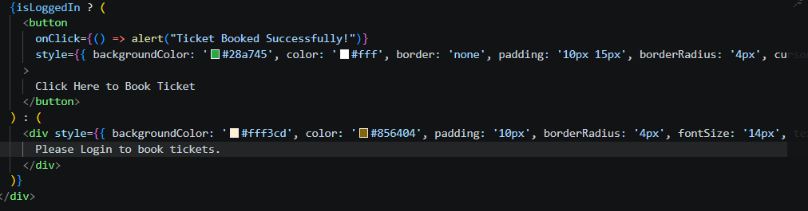

Code Output:
Initial Page
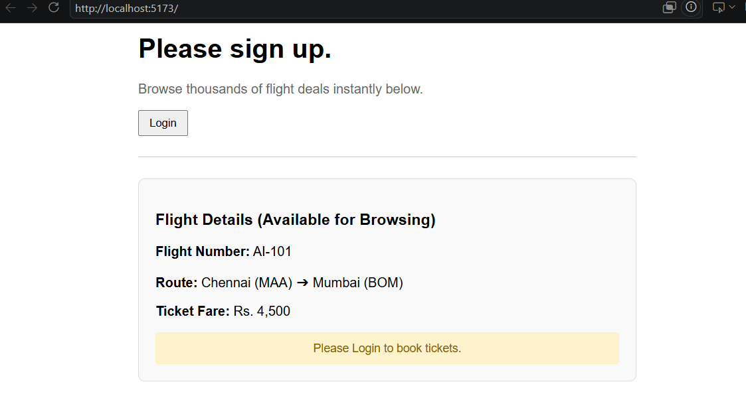
Login Page and When the ticket has been booked.
